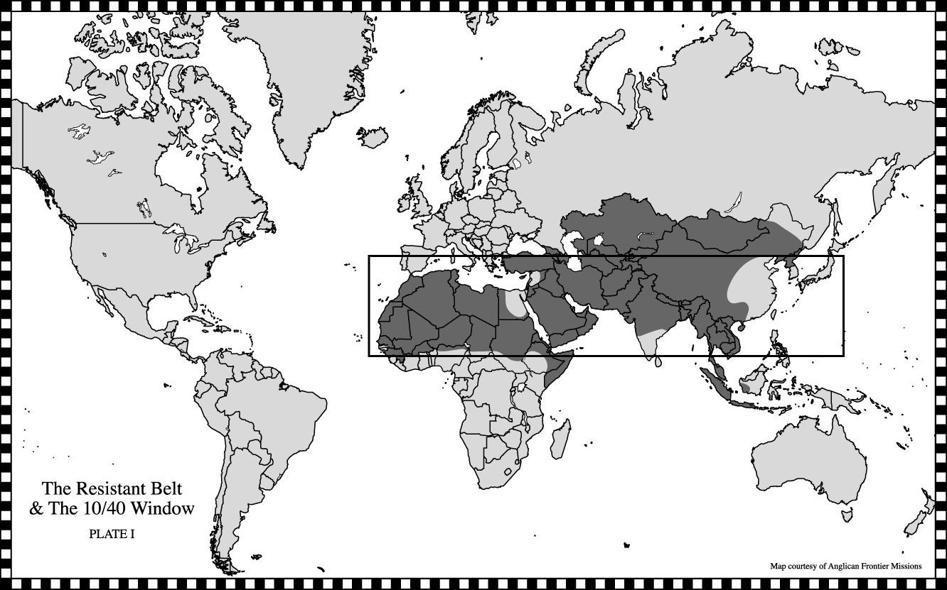

The 10/40 Window includes:
- Approximately 35% of the world’s land area,
- More than 95% of the world’s population who have never heard the Good News of Jesus Christ,
- Over 90% of the world’s poorest and most economically depraved people,
- The world’s most abused women and children, and
- Most of the world’s illiterate.

Anglican Frontier Missions
P.O. Box18038 Richmond VA 23226 – 804/355-8468 – www.afm-us.org
Focusing on the 25 largest and least evangelized people groups of the10/40 Window

The Rev. Canon Dr. B. W. Pete Wait III & Dr. Shirleen S. Wait
Pastors to Missionaries, Anglican Frontier Missions
962 Ocean Blvd, Atlantic Beach FL 32233; 904/249-6696; 904/249-6685 (fax) shirleenwait@earthlink.net
