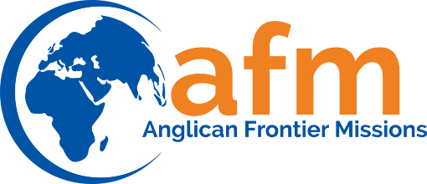
Privacy Policy

Forms within the website may request users to submit contact information. Under no circumstances will AFM sell or share any of your information with anyone other than the webmaster and co-workers on this web site.

Through our web site or in various venues AFM occasionally requests and collects information that personally identifies you or allows you to be personally contacted. AFM will only collect personal information which you knowingly and voluntarily provide. When you provide us with personal information, we will use it for the purposes for which we requested it. We may also contact you to provide information about AFM related activities, programs, or special events that we believe may interest you. You will always have an immediate opportunity to decline further such communication.

Anglican Frontier Mission does not share any of your personal information with any third parties, except as required by law. We do not rent, sell or give our mailing list to other individuals or organizations. The information you provide us may be tabulated for statistical purposes and those results may be provided to others, but you will not be identified in those results. The data may be used to inform you of events and activities and opportunities to support the ministry of AFM We may also use the data to help us evaluate our programs and design future offerings.

All financial transaction information is carefully protected. We take all reasonable precautions against theft, especially electronic theft, of such information.

