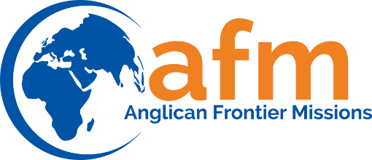

Bequests: Wills and Living Trusts

Giving to AFM through your will or living trust is referred to as a “bequest.” A bequest from your estate may include cash, securities, real estate, and/or personal property. It can be for a specific amount or for a percentage of your estate. But why include AFM your will?

Your bequest to AFM is …

- Comfortable: A bequest allows you to retain your assets throughout your life.
- Flexible: Your bequest can be preferenced to any fund or missionary associated with
AFM.
- Revocable — You may change the beneficiaries of your estate at any time.
- Tax Wise — A charitable gift through your estate may reduce estate taxes.

How Do I Make a Bequest to AFM?

If you are writing your will or living trust, you will need to include specific language that correctly identifies your support of AFM. If you already have a will, you can add an amendment or codicil to your existing estate plan. (If you already have a living trust, you would simply modify the language, directing your trustee to make the desired distributions.)

For Sample Language, click below:

- Unrestricted Bequest (For AFM-determined fund)
- Preferenced Bequest (for a fund you define)

Please Notify AFM of Your Bequest

If you have already included the AFM in your estate plan, please let us know!
Informing AFM does not obligate you or your estate in any way; it simply helps AFM fully understand your gift intentions and ensures that there is a plan in place for implementing them. You have the freedom to change your bequest at any time.

Finally, AFM does not provide legal, tax or financial advice. We strongly recommend that you consult professional advisors on all legal, tax or financial matters, including gift planning considerations. To ensure compliance with certain IRS requirements, we disclose to you that this communication (including any attachments) is not intended or written to be used, and cannot be used, for the purpose of avoiding tax-related penalties.

Preferenced Bequest: For a Purpose You Define

I bequeath to Anglican Frontier Missions, a Virginia non-profit corporation located in Richmond, Virginia, the sum of $__________________ [or property described herein] to be preferenced for the following account or fund: ______________________________________.

OR

I bequeath all the rest of my estate [or _____ percent (_%) of the rest of my estate] to Anglican Frontier Missions, a non-profit corporation located in Richmond, Virginia to be preferenced for the following account or fund: ___________________________________________________________.

Unrestricted Bequest (For AFM's Unrestricted Use)

I bequeath to Anglican Frontier Missions, a Virginia non-profit corporation located in Richmond, Virginia, the sum of $__________________ [or property described herein] to be used by Anglican Frontier Missions for its general purposes.

OR

I bequeath all the rest of my estate [or ___ percent (%) of the rest of my estate] to Anglican Frontier Missions, a Virginia non-profit corporation located in Richmond, Virginia, to be used by Anglican Frontier Missions for its general purposes.

