SUGGESTED DONATION ~
Books: US $12
Video: US $15
Book/Video | Quantity | Suggested Donation
 | Additional Donation:
 |  | TOTAL ENCLOSED DONATION:

Name

Address

City State/Province/County Zip/Postal Code

Country Phone ( ) Email

I would like to receive E-Newsletters from AFM (prayer requests, updates from missionaries, etc.)
Privacy policy: Under no circumstances will AFM sell or share any of your information with anyone other
than the webmaster and co-workers on this web site.

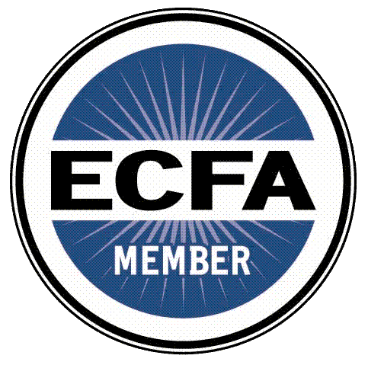

Mail this form to:
P.O. Box 18038
Richmond, VA 23226

We accept cash or checks. Please make all checks payable to Anglican Frontier Missions.

